**SEMESTER 4 PROJECT WORK**

BY SOUVIK SAHA & SOURAV SAHA ,

CLASS-PG 2

SEMESTER- 4

**Two Treatment Two Period Crossover Design For Recurring Disease:**

Here we have to create a probability model regarding Recurrence of Diseases over certain time periods and upon using various treatments(namely,drugs). For the present case we consider two treatments, say A and B, and consider two time periods. The probability model is created as follows:-

Let k=treatment used in first time period = A,B; k k ' = treatment used in second time period, given that treatment k(not equal to k ' ) is used in first time period = AB,BA.

Now, let X k = Number of recurrence of a chronic disease with treatment k in first time period;

and X k k ' = Number of recurrence of a chronic disease with treatment k ' in second time period, provided treatment k(not equal to k ' ) was applied in first time period.

Also, let U = Prognostic variate or covariate, assumed to remain same for a patient in both time periods; like age, sex, some genotype and so on. Suppose U is assumed to be a ordinal categorical variable with

P[U = u] = π u , say, such that [mathop [subsup [symbol sum] [char u mathalpha][char = mathalpha][char 0 mathalpha] [char G mathalpha]]] π u = 1, 0< π u <1 for all u ranging from 0 to G.

Now we propose the following probability models:-

* X k |U=u &thksim; Poisson distribution with E( X k |U=u ) = λ k * a G-u , where a is a known prognostic index, 0<a<1.
* X k k ' | X k = x k ,U=u &thksim; Poisson distribution with
* E( X k k ' | X k = x k ,U=u ) = ( ( λ k k ' + β *( λ k k ' - λ k ) ) * a G-u +( β * x k ) ) ( 1+ β )

Now, if N k patients are assigned to treatment k in first period, k = A,B, then N A + N B = N, where N is some prefixed number.

Now, we define δ ki = 1 if i th patient is assigned to treatment k and δ ki = 0 otherwise.

Let us define S k = ∑ i=1 N δ ki * X ki and S k k ' = ∑ i=1 N δ ki * X k k ' i . Also note that N k = ∑ i=1 N δ ki .

Now, E( S k π * N k ) = λ k and E( S k k ' π * N k ) = λ k k ' .

Again, Var( S k π * N k ) → 0 as N → ∞ and Var( S k k ' π * N k ) → 0 as N → ∞ with min.{ N A , N B } → ∞ .

Thus, ( S k π * N k ) and ( S k k ' π * N k ) are the consistent estimators of λ k and λ k k ' respectively.

To avoid the estimates of the above estimators from 0, we adjust the estimates as

λ k ˆ = S k +( 1/2 ) π *( N k +1 ) and λ k k ' ˆ = S k k ' +( 1/2 ) π *( N k +1 ) where k = A,B and k k ' = AB,BA.

Now, let us define log λ k = α k and log λ k k ' = α k ' + φ ; k = A,B; kk' = AB,BA; where α k is the main effect due to treatment k and φ is period effect.

Now, we want to test the effects of the two treatments, that is, we want to test

H 0 : effects of two treatments are same.

against H 1 : treatment A is superior to treatment B; which is similar to

H 0 : α A = α B against H 1 : α A > α B .

Now, log λ B -log λ A = α A - α B and log λ AB -log λ BA = α A - α B . Thus,

α A - α B =( 1/2 ) *( log λ B -log λ A +log λ AB -log λ BA ) .

Hence, ( α A - α B ) ˆ =( 1/2 ) ˆ *( log λ B ˆ -log λ A ˆ +log λ AB ˆ -log λ BA ˆ ) = ψ ( λ A ˆ , λ B ˆ , λ AB ˆ , λ BA ˆ )

Thus, using Delta method (first order), we get E[ ψ ( λ A ˆ , λ B ˆ , λ AB ˆ , λ BA ˆ ) ] = ( α A - α B )

and ( N 2 ) ( ( α A - α B ) ˆ - ( α A - α B ) ¯ ) → N(0,2* σ 2 ) in distribution.

Again, under H 0 : α A = α B , λ A = λ B = λ 1 and λ BA = λ AB = λ 2 ,

σ B 2 = σ A 2 = σ 11 , σ AB 2 = σ BA 2 = σ 22 and σ A,AB = σ B,BA = σ 12 .

Thus under H 0 , σ 2 =( σ 11 2* λ 1 2 ) +( σ 22 2* λ 2 2 ) +( σ 12 λ 1 * λ 2 ) = σ 0 2 . Agsin, under equal allocation weight,

λ 1 = ( λ A + λ B ) 2 and λ 2 = ( λ AB + λ BA ) 2 . Thus, the statistic used for testing the effects of treatments to be similar or different is T 1 = N 2 ( ( α A - α B ) ˆ ) σ 0 ˆ and under H 0 , T 1 → N(0,1) in distribution as N → ∞ .

Here, σ 0 2 ˆ =( σ 11 ˆ 2* λ 1 2 ˆ ) +( σ 22 ˆ 2* λ 2 2 ˆ ) +( σ 12 ˆ λ 1 ˆ * λ 2 ˆ ) ; where λ 1 ˆ = λ A ˆ + λ B ˆ 2 and λ 2 ˆ = λ AB ˆ + λ BA ˆ 2 .

Thus we reject H 0 at 5% level of significance if T 1 > τ 0.05 , that is, T 1 >1.645 .

* Another method of testing the effects of treatments would be to use the approach of testing as in Chatterjee and De (1972). In this approach we are to test H 0 : λ A = λ B , λ AB = λ BA against H 1 : λ A &ges; λ B , λ BA &ges; λ AB with strict inequality in atleast one case.

Now, we observe that

N ( λ A ˆ - λ B ˆ - λ A - λ B ¯ , λ BA ˆ - λ AB ˆ - λ BA - λ AB ¯ ) → N 2 ( 0 &Tilde; ,( 2( σ A 2 + σ B 2 ) -2( σ A,AB + σ B,BA ) -2( σ A,AB + σ B,BA ) 2( σ BA 2 + σ AB 2 ) ) ) .

Thus under H 0 , we get

N ( λ A ˆ - λ B ˆ , λ BA ˆ - λ AB ˆ ) → N 2 [ ( 0 0 ),2( 2 σ 11 -2 σ 12 -2 σ 12 2 σ 22 ) ] in distribution.

Now let us define D 1 = N ( λ B ˆ - λ A ˆ ) 2 σ 11 ˆ and D 2 = N ( λ AB ˆ - λ BA ˆ ) 2 σ 22 ˆ . Then,

( D 1 , D 2 ) → N 2 [ ( 0 0 ),( 1 ρ 0 ρ 0 1 ) ] , in distribution, under H 0 where ρ 0 = - σ 12 σ 11 σ 22 . Now we use the following test statistic to perform our required test, as provided using approach of Chatterjee and De :-

T 2 ={ ( D 1 2 + D 2 2 -2 ρ 0 ˆ D 1 D 2 ) / 1-( ρ 0 ˆ ) 2 ; D 1 >0, D 2 >0 D 2 - ρ 0 ˆ D 1 / 1-( ρ 0 ˆ ) 2 ; D 2 &ges; D 1 , D 1 &les; 0 D 1 - ρ 0 ˆ D 2 / 1-( ρ 0 ˆ ) 2 ; D 1 &ges; D 2 , D 2 &les; 0 .

Here we reject H 0 in favour of H 1 at level of significance γ if P H 0 [ T 2 >c ] = γ , where c=c( ρ 0 ) and c( ρ 0 ) is either obtained by simulation or by using tables given by Chatterjee and De. In the present scenario, we have obtained value of c( ρ 0 ) using simulation.

* Another method of testing the effects of treatments would be the method of Multiple Testing Procedure. In this method, we define another test statistic, namely T 3 , which is as follows:-

**T 3 =max{ D 1 , D 2 } where D 1 = N ( λ B ˆ - λ A ˆ ) 2 σ 11 ˆ and D 2 = N ( λ AB ˆ - λ BA ˆ ) 2 σ 22 ˆ .**

Here the critical region for rejecting H 0 : λ A = λ B , λ AB = λ BA against H 1 : λ A &ges; λ B , λ BA &ges; λ AB will be { T 3 > c * } where c * is obtained from size condition using Monte Carlo simulation.

**After obtaining the test statistic T 1 , T 2 and T 3 , we compute their power under different parametric choices of ( λ A , λ B , λ AB , λ BA ) for known values of a, β ,{ π u ,u=0,1,2,......,G} .**

Now, for the computational part, we consider six parametric choices of ( λ A , λ B , λ AB , λ BA ) and two different values of β . Here we consider a to be a variable having a certain fixed known value. Also, we consider G=2, that is, π u =P[ U=u ] = 1 3 , u=0,1,2 .

Here we consider the following parametric choices of ( λ A , λ B , λ AB , λ BA ) as :-

1. ( λ A , λ B , λ AB , λ BA ) ≡ ( 1.5,2,1.9,1.6 )
2. ( λ A , λ B , λ AB , λ BA ) ≡ ( 1.8,2.5,2.4,2 )
3. ( λ A , λ B , λ AB , λ BA ) ≡ ( 2,3,2.8,2.3 )
4. ( λ A , λ B , λ AB , λ BA ) ≡ ( 2.1,2.5,2.9,2.6 )
5. ( λ A , λ B , λ AB , λ BA ) ≡ ( 2.5,3,2,1.5 )
6. ( λ A , λ B , λ AB , λ BA ) ≡ ( 3,5,2.5,2 )

Again we consider two different values of β as follows:-

1. β =0.8
2. β =0.7

Now, to compute the values of T 1 , T 2 and T 3 , we need to obtain samples through simulation. Here we consider samples of sizes 80,100,120,150,200 and 300 to obtain values of T 1 , T 2 and T 3 . Now, we repeat our procedure 10000 times to obtain 10000 values of T 1 , T 2 and T 3 . Then we compute empirical power of T 1 , T 2 and T 3 .Thus we perform the above procedure using the following R codes:-

* For a=0.9 and β =0.8 :-
  1. For parametric choice ( λ A , λ B , λ AB , λ BA ) ≡ ( 1.5,2,1.9,1.6 ) and sample sizes (80,100,120) :

[,1] [,2] [,3]

[1,] 0.3816 0.7147 0.4782

[2,] 0.4806 0.7052 0.4780

[3,] 0.5895 0.7046 0.4637

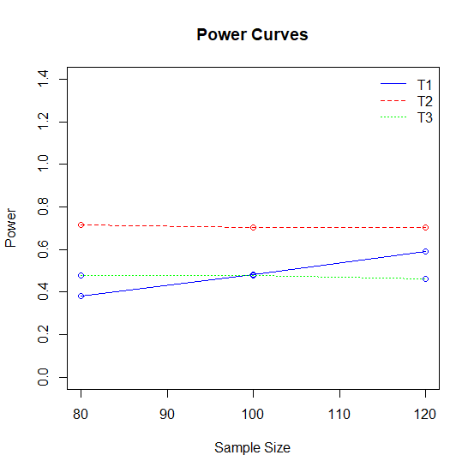

2)For parametric choice ( λ A , λ B , λ AB , λ BA ) ≡ ( 1.5,2,1.9,1.6 ) and sample sizes (150,200,300) :

[,1] [,2] [,3]

[1,] 0.7004 0.8480 0.9661

[2,] 0.9202 0.9700 0.9962

[3,] 0.7222 0.8502 0.9559

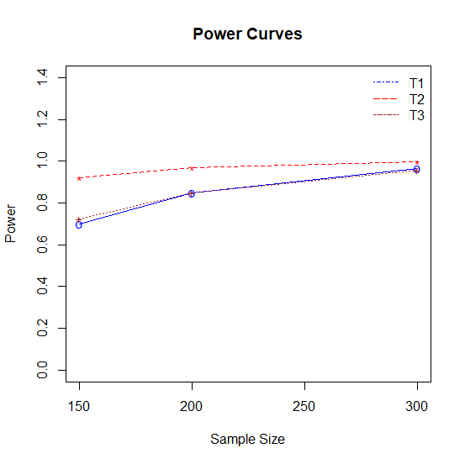

**3.**

For parametric choice ( λ A , λ B , λ AB , λ BA ) ≡ ( 1.8,2.5,2.4,2 ) and sample sizes (80,100,120) :

[,1] [,2] [,3]

[1,] 0.5861 0.7225 0.4809

[2,] 0.7081 0.7039 0.4696

[3,] 0.8068 0.7015 0.4697

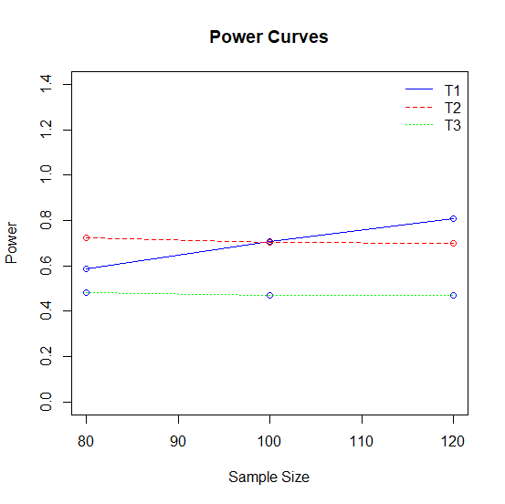

**4.**

For parametric choice ( λ A , λ B , λ AB , λ BA ) ≡ ( 1.8,2.5,2.4,2 ) and sample sizes (150,200,300) :

[,1] [,2] [,3]

[1,] 0.8980 0.9679 0.9983

[2,] 0.9842 0.9969 0.9998

[3,] 0.9010 0.9658 0.9976

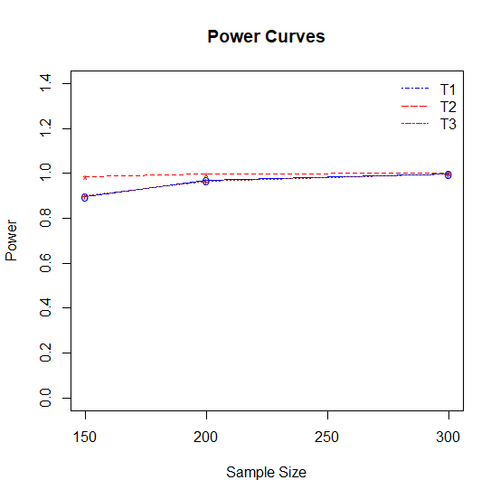

**4.**

For parametric choice ( λ A , λ B , λ AB , λ BA ) ≡ ( 1.8,2.5,2.4,2 ) and sample sizes (150,200,300) :

[,1] [,2] [,3]

[1,] 0.8980 0.9679 0.9983

[2,] 0.9842 0.9969 0.9998

[3,] 0.9010 0.9658 0.9976



**5.**

For parametric choice ( λ A , λ B , λ AB , λ BA ) ≡ ( 2,3,2.8,2.3 ) and sample sizes (80,100,120) :

[,1] [,2] [,3]

[1,] 0.8264 0.7178 0.4788

[2,] 0.9172 0.7046 0.4784

[3,] 0.9622 0.6962 0.4697

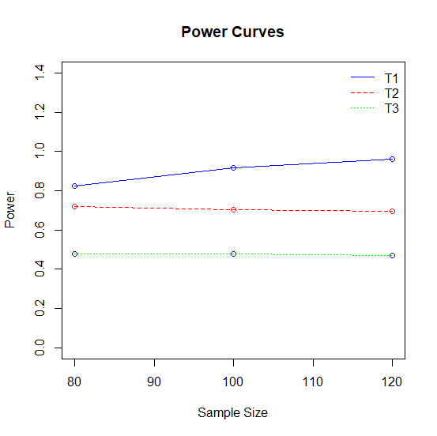

**6.**

For parametric choice ( λ A , λ B , λ AB , λ BA ) ≡ ( 2,3,2.8,2.3 ) and sample sizes (150,200,300) :

[,1] [,2] [,3]

[1,] 0.9888 0.9987 1

[2,] 0.9993 1.0000 1

[3,] 0.9878 0.9983 1

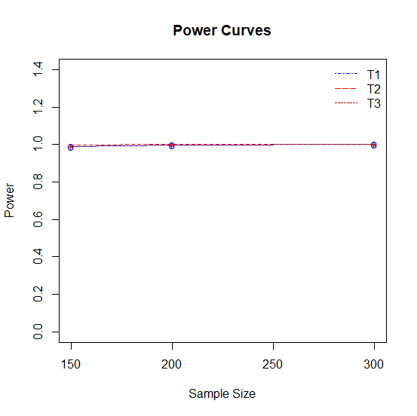

7) For parametric choices of ( λ A , λ B , λ AB , λ BA ) ≡ ( 2.6,2.9,2.3,2.1 ) and sample sizes (80,100,120).

[,1] [,2] [,3]

[1,] 0.0685 0.7100 0.4809

[2,] 0.0881 0.7150 0.4867

[3,] 0.1127 0.7052 0.4592

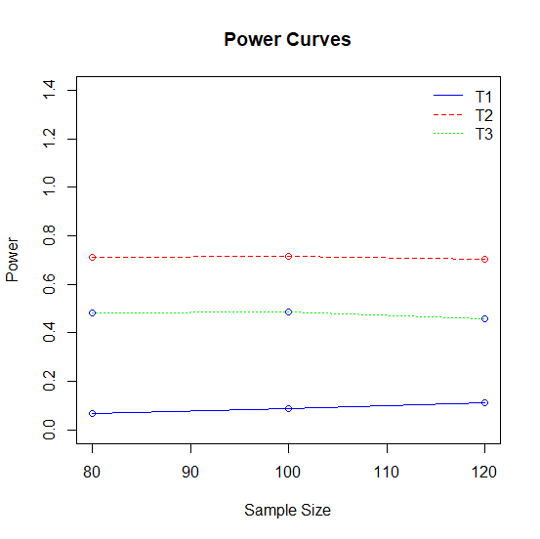

8) For parametric choices of ( λ A , λ B , λ AB , λ BA ) ≡ ( 2.6,2.9,2.3,2.1 ) and sample sizes (150,200,300).

[,1] [,2] [,3]

[1,] 0.1427 0.2132 0.3640

[2,] 0.4753 0.5877 0.7384

[3,] 0.2820 0.3459 0.4575

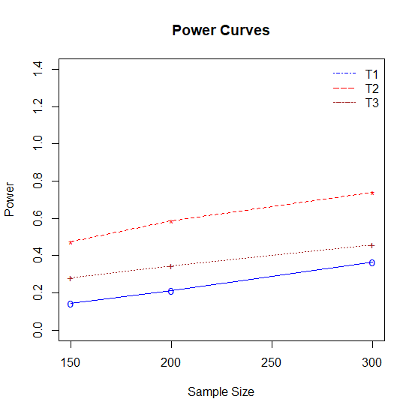

9)For parametric choice ( λ A , λ B , λ AB , λ BA ) ≡ ( 2.5,3,2,1.5 ) and sample sizes (80,100,120) :

[,1] [,2] [,3]

[1,] 0.4262 0.7148 0.4785

[2,] 0.5633 0.7033 0.4636

[3,] 0.6572 0.7106 0.4636

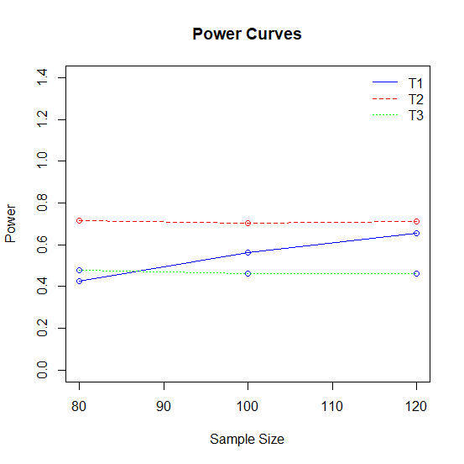

10)For parametric choice ( λ A , λ B , λ AB , λ BA ) ≡ ( 2.5,3,2,1.5 ) and sample sizes (150,200,300) :

[,1] [,2] [,3]

[1,] 0.7870 0.9048 0.9875

[2,] 0.9666 0.9921 0.9996

[3,] 0.7704 0.8851 0.9779

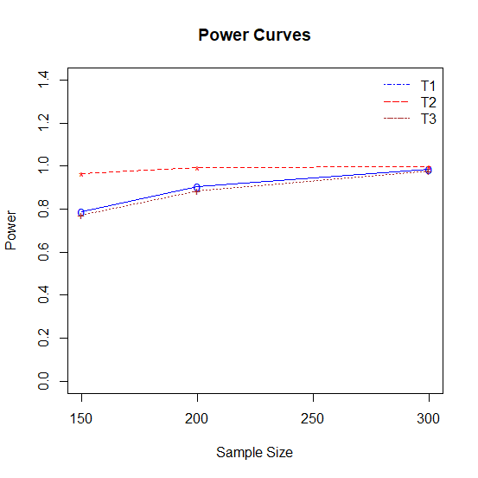

11)For parametric choice ( λ A , λ B , λ AB , λ BA ) ≡ ( 3,5,2.5,2 ) and sample sizes (80,100,120) :

[,1] [,2] [,3]

[1,] 1e-04 0.7035 0.4529

[2,] 1e-04 0.7090 0.4790

[3,] 0e+00 0.7109 0.4713

